**System Design**

**Introduction**

System design plays an important role in any project. We have tried to maintain a simple and practical design and combined all the expected features with a simple, scalable design. More about model structure and data flow diagrams is explained in the next sections.

**Sequence Diagram (High Level Design)**

A Sequence diagram is an interaction diagram that shows how objects operate with one another and in what order. It is a construct of a message sequence chart. A sequence diagram shows object interactions arranged in a time sequence. It depicts the objects involved in the scenario and the sequence of messages exchanged between the objects needed to carry out the functionality of the scenario. This allows the specification of simple runtime scenarios in a graphical manner.

General information regarding the vital statistics (age, weight, gender, height, and nutritional deficiencies) of the user is stored in a central repository that can be altered as and when the quantitative values change. The necessary nutritional requirements based on these values are extracted at which point the user can additionally but not necessarily enter nutritional needs. This data is then processed and fed into an intelligent algorithm that populates a list of ingredients that would contain the necessary nutrition values. At this stage, the user can specifically opt-out of the suggested ingredients as per personal preference and this would trigger another analysis phase until the user’s ingredient preferences are met. This set of ingredients is merged with a list of ingredients that are available to the user to create a balance of cookable ingredients. Only using the suggestions from the algorithm would lead to an overwhelming list of only nutritional requirements. An optional input on the user’s preference for cuisine is taken and the web is scraped for food products that can be prepared from this set of ingredients.

The nutritional value of the scrapped products is calculated and they are ranked with respect to the nutritional requirements and preferences of the user. This list is then suggested to the user in the form of recipes for the ranked food products.

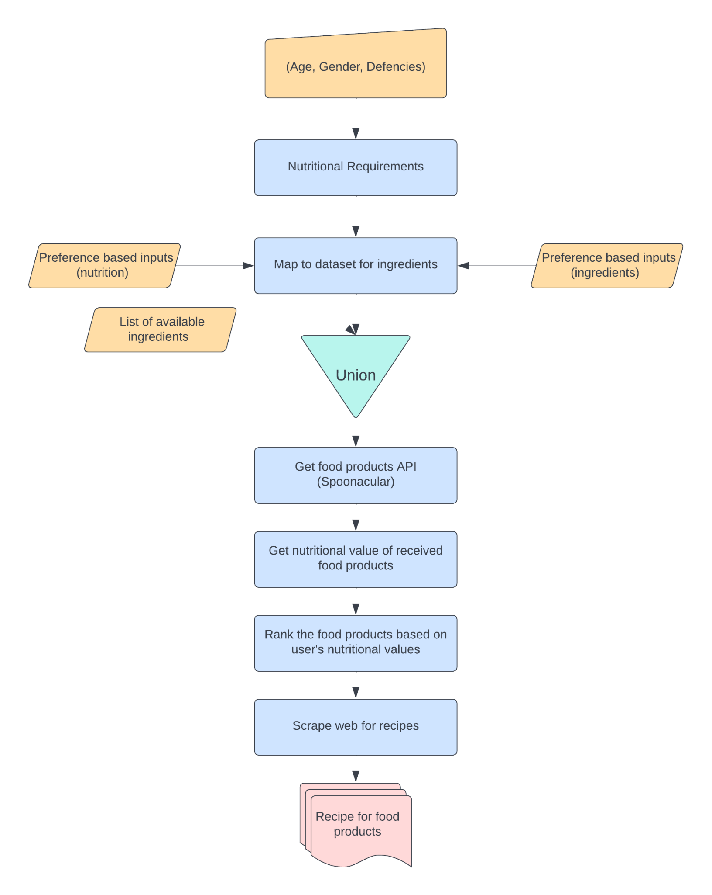

**Fig 1 :** High Level Design

**Low Level Design**

The diagrams below represent the working of each of the functional components in brief.

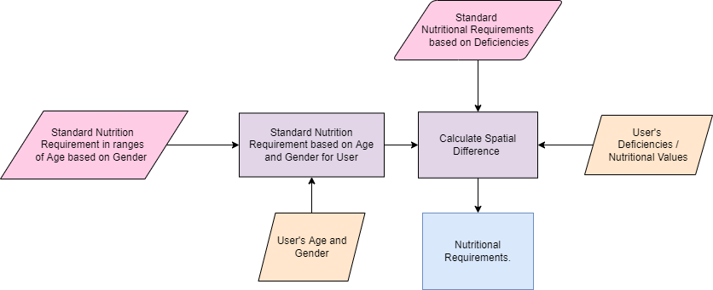

**Fig. 2** : Nutritional Requirements

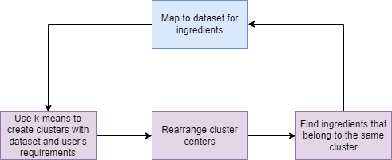

**Fig. 3** : Map to dataset for ingredients

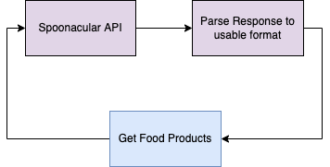

**Fig. 4** : Get food products

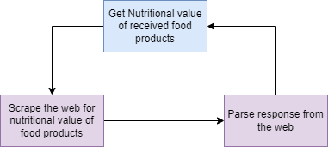

**Fig. 5** : Get nutritional value of received food products

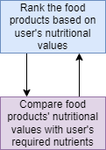

**Fig. 6 :** Rank the food products based on user’s nutritional values

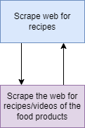

**Fig. 7** : Scrape web for recipes

**Data Flow Diagram**

This represents the data flow from functional components to data source and intermediate helper blocks throughout the lifecycle of the computation.

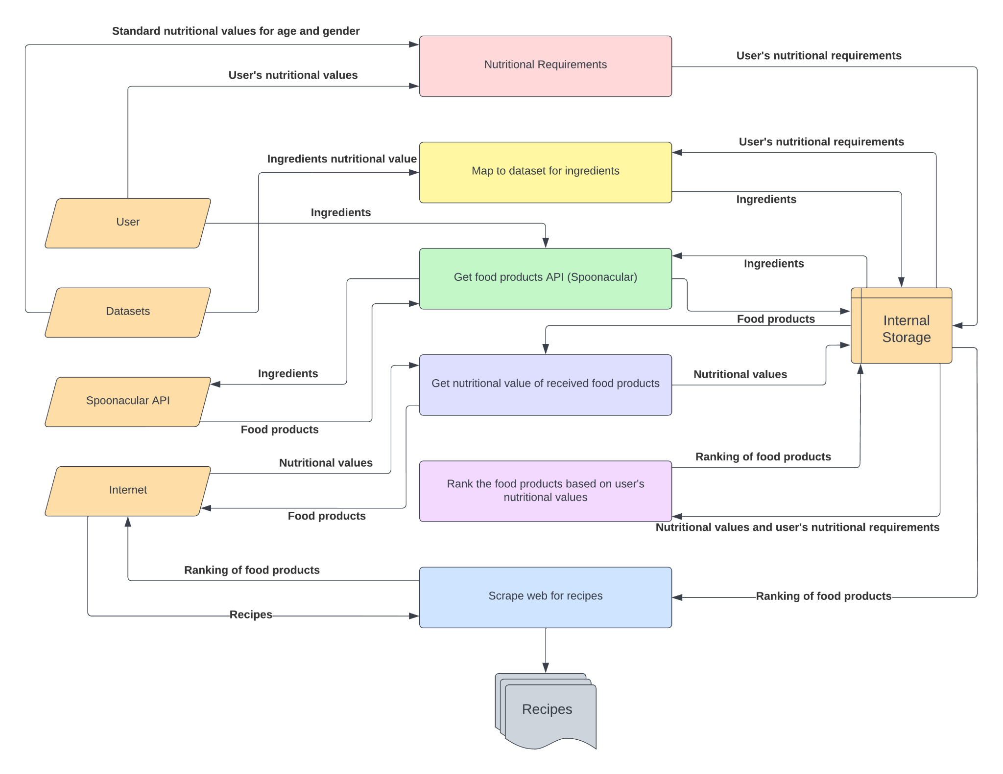

**Fig. 8** : Data flow diagram